ITECH3101: Assessment Task 1

Software installations and

review basic concept

Written By : Boris Wijaya (30393908)

**Software installations**

1. Installation of SAS OnDemand for Academics

Step 1

I navigate to the <https://welcome.oda.sas.com/login> link from the browser.

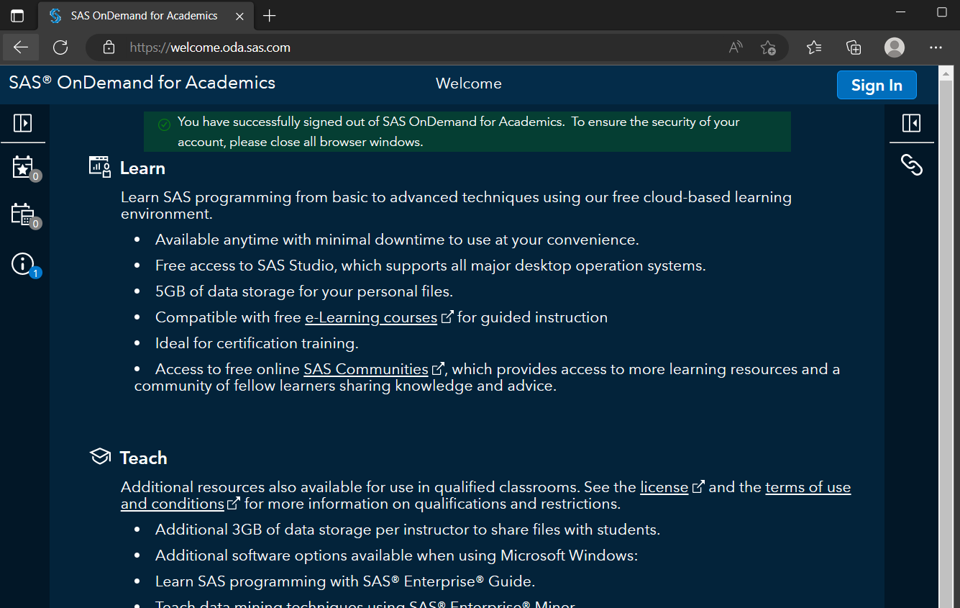

Step 2

I click the “Sign In” button to creat my SAS profile, so I can have access to the SAS dashboard main page.

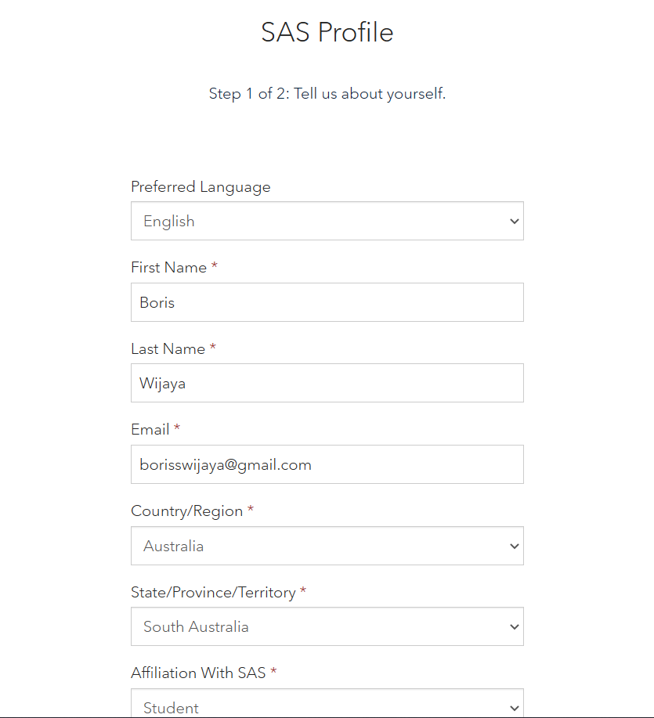

(Source: Taken by Boris Wijaya - 30393908)

Step 3

After creating my personal profile, I’m able to access the SAS dashboard page.

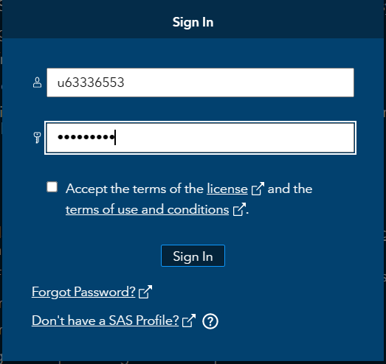

The display of SAS dashboard.

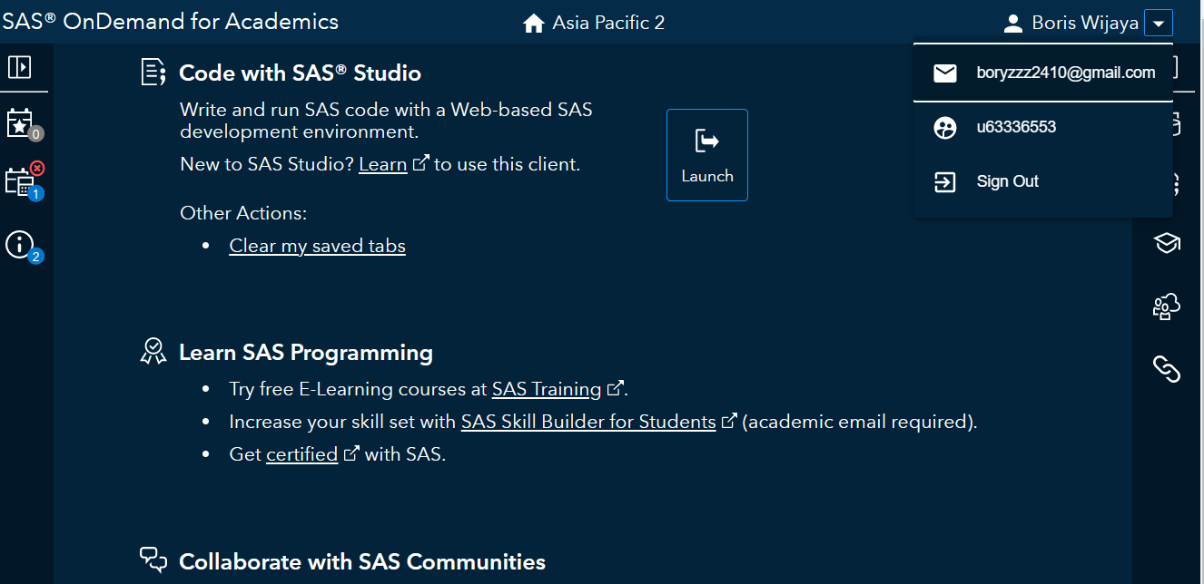

Step 4

From dashboard page I click “Launch” button to access the SAS studio.

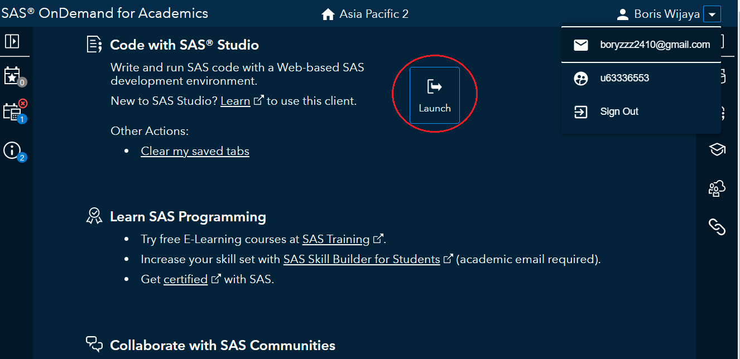

Step 5

Next, I test SAS studio by writing my first SAS program and running it.

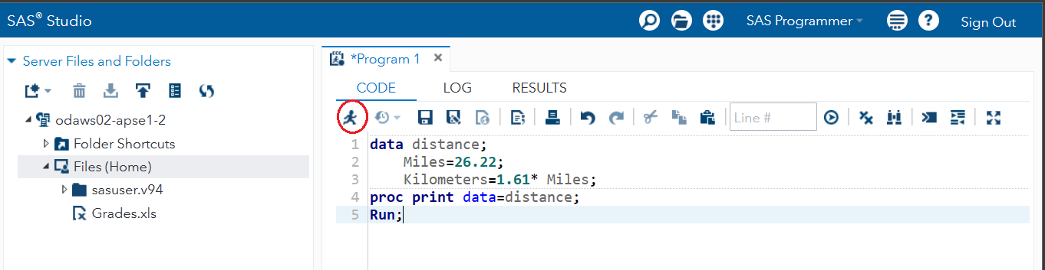

It then shows the result as follows and proves that the SAS studio is working properly.

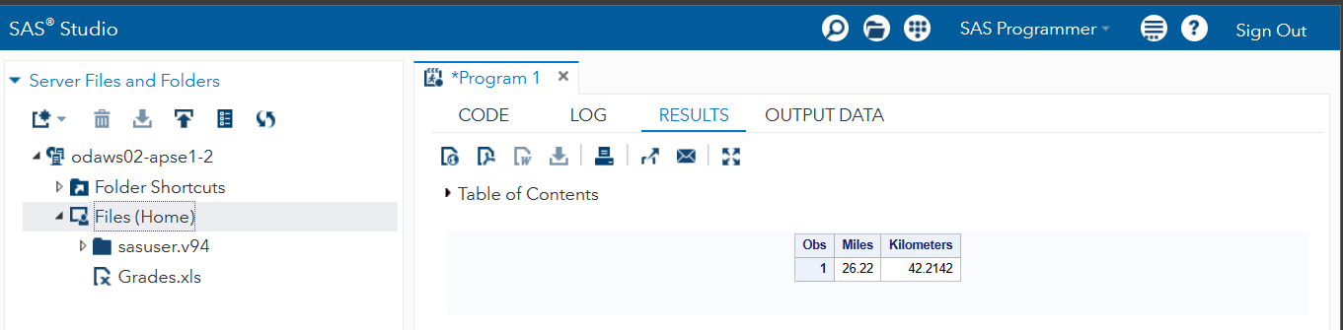

1. Installation of Tableau Public

Step 1

I Navigate to the <https://public.tableau.com/en-us/s/download> provided in Moodle to install Tableau Public.

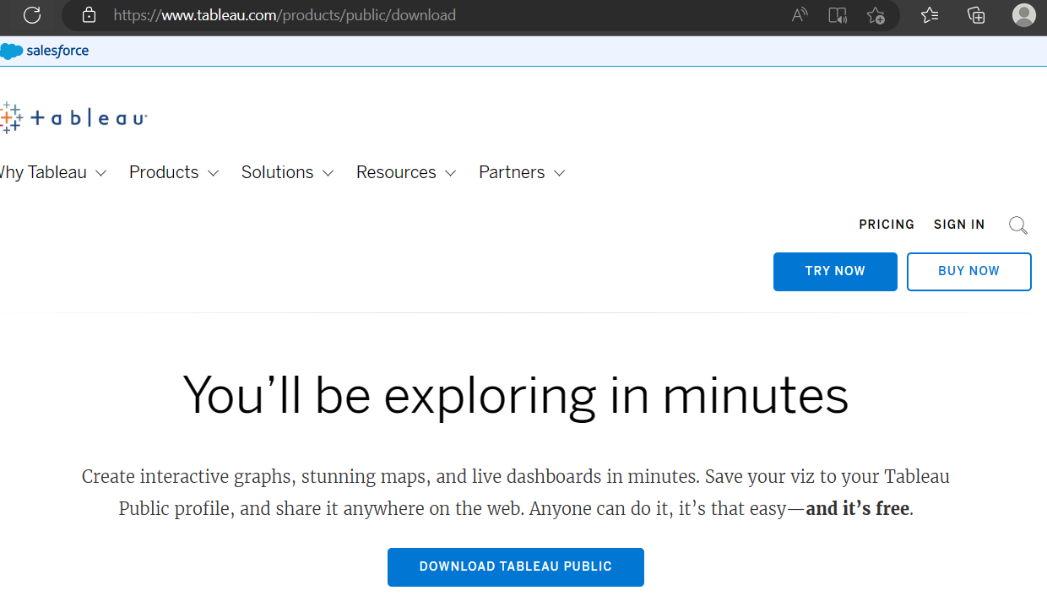

Step 2

I Create my personal Tableau details by clicking the “Download Tableau Public“ button.

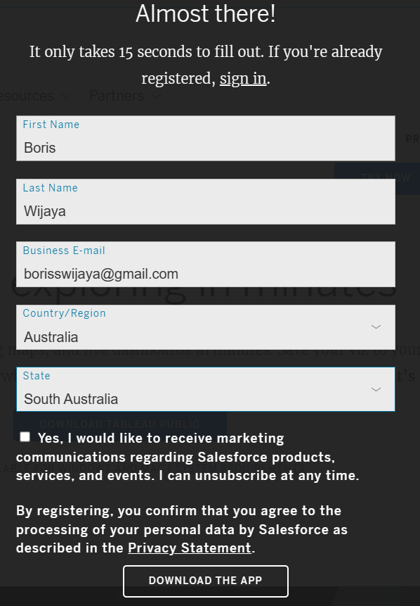

Step 3

After entering the personal detail, click the “DOWNLOAD THE APP” button and it will automatically start downloading on my computer.

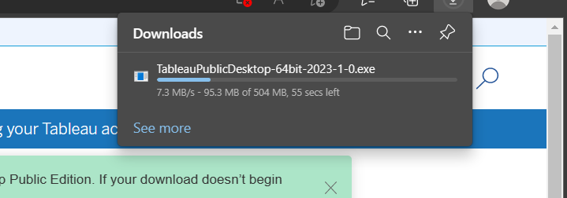

Step 4

Next, I open the downloaded file and was directed to the screen below

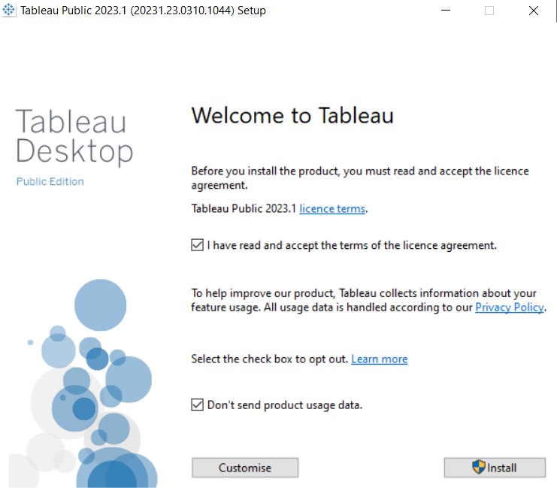

Step 5

I clicking the install button and wait for the system to finish installing the Tableau app.

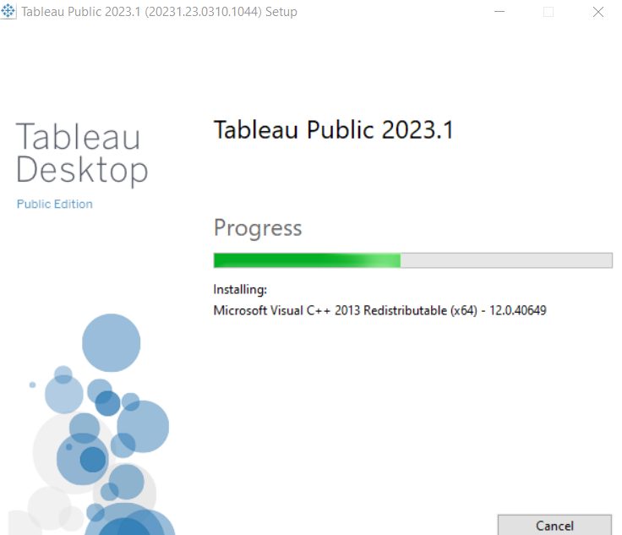

After it finish the Tableau app will automatically appear on my desktop computer.

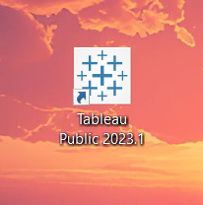

Step 6

I test the Tableau app by opening it, then surely it open the start page indicate that the installation is correct.

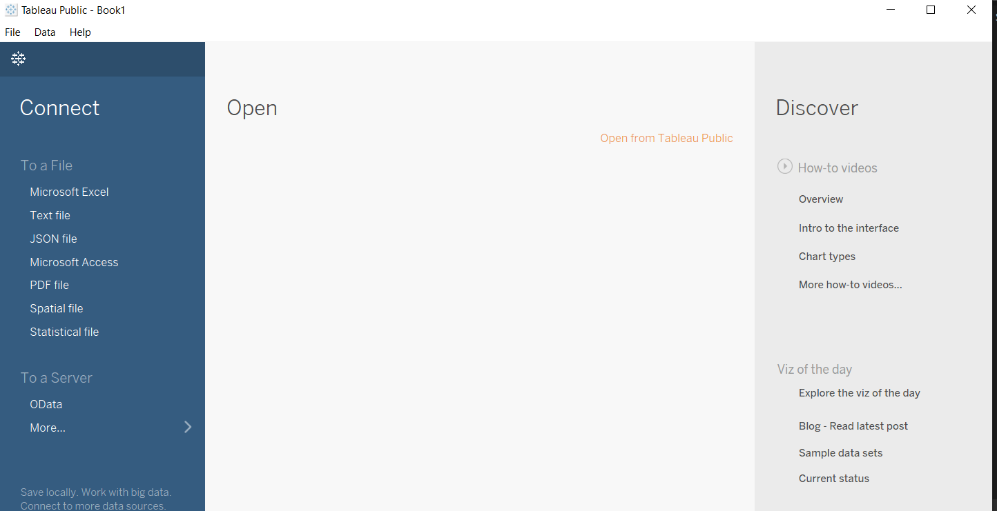

**Answering Questions**

1. What does Managerial Decision-Making mean? Discuss this concept in the context of the four-step approach to decision-making.
2. Explain why decision-makers, using the same decision-making process, might end up with 2 different decisions.
3. Discuss the support that AI can provide to decision-makers.
4. What are the reasons for the recent emergence of visual analytics?